From the editor
JANUARY 2, 2023
VOL. 2 ISS. 8
It is exciting to release the second-to-last newsletter of Volume 2 and Fall 2022
of ASPIRE. ASDRP wishes everyone a happy new year, and a happy fall-spring
transition into 2023! There are several exciting features in this issue: the
announcement of the Senior Scholar-Scientist Award, introductions to two of the newest members of ASDRP staff, publication announcements, and information about the Fall 2022 Symposium and Research Expo.

Thank you all for reading!

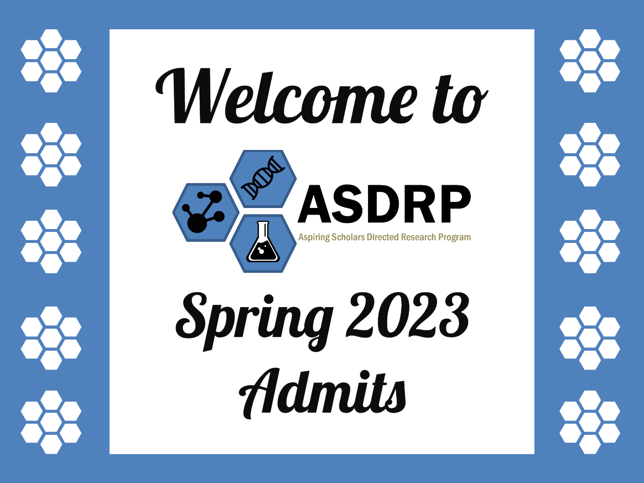

Announcing our 2022 Recipient of the Senior Scholar-Scientist Award

Sarah Su, Los Altos High School, Njoo Group (Organic Chemistry)

Sarah joined ASDRP in her first semester of freshman year back in 2019, where she began research in the Njoo group in organic chemistry / chemical biology (www.njoolab.org). Today, 3+ years later, Sarah is an accomplished researcher with an impressive list of eight published/accepted original research peer-reviewed publications, one application note / white paper, seven conference proceedings / conference abstracts, and six oral presentations, and a research skill base in organic synthesis, medicinal chemistry, drug discovery, computer modeling, NMR spectroscopy, and chemical biology that outmatches most undergraduates.

From her advisor

The first project that Sarah worked on was on berberine, a bioactive isoquinoline alkaloid small molecule isolated from a plant whose therapeutic use in treating human disease dates back several centuries in ancient southeast Asia. A few years ago, we and others reported could act as a photosensitizer to excite ground state triplet oxygen into excited state triplet oxygen, thereby acting as photosensitizer for light-induced biological activity, and Sarah has published on this extensively [Photochemical analog (Sun, et al. JEI 2021); Initial antibacterial SAR (Sun, et al. JEI 2020)]. Specifically, Sarah led our first efforts on non-canonical uses of benchtop NMR spectroscopy to use benchtop NMR to quantify 1O2 by trapping it with a cyclic 1,3-diene to form [2.2.2]bicyclo endoperoxides, and we now have two publications on this, along with an application note co-developed with Nanalysis [App Note, Interview Video]. In parallel, Sarah has also grown a great deal of expertise in using computer modeling for understanding reactive intermediates and small molecule drug candidates (Link to Sarah's Ted Talk here), first in our use of DFT, TD-DFT, and MD in our computational SAR of berberine analogs as DNA-Gquad stabilizing agents (Sun/Ashok, et. al., JEI 2020), later in our SARS-CoV-2 Mpro inhibitors project (Sun, et al., J. Res. HS 2020).
When we transitioned the project to work on carmofur, a small molecule originally developed for colorectal cancer but later repurposed for SARS-CoV-2, Sarah was involved in a high throughput analog screen of novel carmofur analogs against wild type and mutant variants of SARS-CoV-2 (Luk, et al., manuscript accepted, 2022). Late in 2022, Sarah was part of a team that worked on our group’s flagship paper of the year, using 19F NMR spectroscopy for monitoring (Chen, et al. ChemRXiv 2022), specifically for tracking the reactive intermediates present in complex multicomponent reactions. This project was shared at STEM Week at Los Altos High School (Link to talk: https://www.youtube.com/watch?v=vIJ-C1tVUbA) and is now under peer review for publication! Currently, Sarah works on several projects in the interface of chemical synthesis, chemical biology, catalysis, and small molecule drug discovery, including our development of difluorocyclopropanation catalyst strategies as well as using stereo- and regio-controlled inverse demand Diels Alder cycloadditions for construction of the tricyclic core of forskolin, a bioactive diterpenoid with therapeutic value in aging research.

A more detailed research profile outlining Sarah’s accomplishments:
SCIENTIFIC PUBLICATIONS
- Chen, Rosie; Singh, Pratyush; Su, Sarah; Kocalar, Selin; Wang, Xina; Mandava, Neha; Venkatesan, Srishti; Ferguson, Adrienne; Rao, Aishi; Le, Emma; Rojas, Casey; Njoo, Edward. “Benchtop 19F Nuclear Magnetic Resonance (NMR) Spectroscopy Provides Mechanistic Insight into the Biginelli Condensation towards the Chemical Synthesis of Novel Trifluorinated Dihydro- and Tetrahydropyrimidinones as Antiproliferative Agents.” ChemRxiv 2022. DOI: 10.26434/chemrxiv-2022-1371g-v2 URL: https://chemrxiv.org/engage/chemrxiv/article-details/63905b9b04bc6600d60b2b1c
- Su, Sarah*; Sri Indran, Karthikha*; Pal, Sohie; Le, Emma; Regan, Anika; Jain, Meher; Shah, Aashi; Iglesias, David; Wang, Andrew; Njoo, Edward. “Comparative singlet oxygen photosensitizer efficiency of berberine, rose bengal, and methylene blue by time course nuclear magnetic resonance (NMR) monitoring of a photochemical 4+2 cycloaddition endoperoxide formation.” Journal of Emerging Investigators 2021, online. https://www.emerginginvestigators.org/articles/comparative-singlet-oxygen-photosensitizer-efficiency-of-berberine-rose-bengal-and-methylene-blue-by-time-course-nuclear-magnetic-resonance-nmr-monitoring-of-a-photochemical-4-2-cycloaddition-endoperoxide-formation/pdf
- Su, Sarah; Le, Emma; Sri Indran, Karthikha; Pal, Sohie; Regan, Anika; Jain, Meher; Shah, Aashi; Njoo, Edward. “Comparative singlet oxygen production analysis of reduced berberine analogs via a 4+2 Diels Alder-like cycloaddition monitored using nuclear magnetic resonance (NMR) spectroscopy” Journal of Emerging Investigators, manuscript accepted.
- Luk, Charissa; Nepani, Tvisha; Bhattercharjee, Shamita; Raman, Thoya; Avadhani, Udbhav; Su, Sarah; Raghavan, Shloka; Mandava, Neha; Chanda, Priya; Rao, Aishi; Wang, Xina; Shah, Aashi; Wu, Jeslyn; Njoo, Edward. “In silico screen of a library of carmofur analogs as potential inhibitors of the SARS-CoV-2 main protease and its variants through homology modeling.” Journal of Research High School 2022, manuscript accepted, in press.
- Sun Stephanie; Hamid, Saira; Su, Sarah; Su, Andrew; Ashok, Bhavesh; Njoo, Edward. "Strain-specific and photochemically-activated antimicrobial activity of berberine and two analogs" Journal of Emerging Investigators 2020. https://www.emerginginvestigators.org/articles/strain-specific-and-photochemically-activated-antimicrobial-activity-of-berberine-and-two-analogs
- Sun, Stephanie; Su, Andrew; Sakhrani, Simran; Ashok, Bhavesh; Su, Sarah; Rajamanickam, Sarada; Njoo, Edward. “Comparative screening of dose-dependent and strain-specific antimicrobial efficacy of berberine against a representative library of broad spectrum antibiotics." Journal of Emerging Investigators 2020.
https://www.emerginginvestigators.org/articles/comparative-screening-of-dose-dependent-and-strain-specific-antimicrobial-efficacy-of-berberine-against-a-representative-library-of-broad-spectrum-antibiotics/pdf
- Sun, Stephanie; Anand, Kavya; Ashok, Bhavesh; Ashok, Ishani; Bajaj, Ayush; Beldona, Varsha; Chattopadhyay, Kushal; Kwan, Audrey; Mageswaran, Karan; Surapaneni, Anvi; Surapaneni, Atri; Verma, Pranjal; Chen, Allen; Kolala, Ria; Liang, Andrew; Poosarla, Ayeeshi; Premnath, Krithikaa; Sri Indran, Karthikha; Wu, Jeslyn; Yuvaraj, Aishwarya; Raj, Harsha; Sathish, Tanish; Shah, Aashi; Su, Sarah; Tran, Kara; Njoo, Edward. "Reactivity-guided de novo molecular design and high throughput virtual screening of a targeted library of peptidomimetic compounds reveals charge-based structure-activity relationship of potential covalent inhibitors of the main protease of SARS-CoV-2." Journal of Student Research 2020, 9(2), 1082. https://doi.org/10.47611/jsrhs.v9i2.1082
https://www.jofsr.org/hs/index.php/path/article/view/1082
- Sun, Stephanie; Ashok, Bhavesh; Su, Andrew; Hamid, Saira; Sri Indran, Karthikha; Shah, Aashi; Su, Sarah; Sakhrani, Simran; Njoo, Edward. "Computational structure-activity relationship (SAR) of berberine analogs reveals both position- and target-dependence in double stranded and G-quadruplex DNA binding." Journal of Emerging Investigators 2020, online.
https://www.emerginginvestigators.org/articles/computational-structure-activity-relationship-sar-of-berberine-analogs-in-double-stranded-and-g-quadruplex-dna-binding-reveals-both-position-and-target-dependence
TECHNICAL PAPERS
- Sarah Su, “Quantitative analysis of singlet oxygen production via a 4+2 endoperoxide cycloaddition by 1H benchtop nuclear magnetic resonance spectroscopy,” Application note co-developed with Nanalysis Corp. Link
CONFERENCE PROCEEDINGS
1. Sarah Su, Emma Le, Meher Jain, Pratyush Singh, Alivia Zhang, Aashi Shah, Anushka Peer, Shelley Li, “Chemical synthesis and ex-vivo evaluation of berberine analogs as DNA-binding singlet oxygen photosensitizers” Proceedings of the Spring 2022 National Meeting of the American Chemical Society (San Diego, CA).
2. Sarah Su*, Emma Le*, “Semisynthesis and Structure Activity Relationship of Novel Berberine Analogs as DNA-Binding Singlet Oxygen Photosensitizers” Virtual Southern California Conferences for Undergraduate Research (2021)
3. Sarah Su, Emma Le, Meher Jain, Pratyush Singh, Alivia Zhang, Karthikha Sri Indran, Sohie Pal, Aashi Shah, Sanhita Nittala, Edward Njoo, “Chemical Synthesis and Ex-Vivo Evaluation of Berberine Analogs as DNA-Binding Singlet Oxygen Photosensitizers” Virtual Southern California Conferences for Undergraduate Research (2021)
4. Sarah Su*, Karthikha Sri Indran*, Sohie Pal, Emma Le, Anika Regan, Meher Jain, Aashi Shah, David Iglesias, Andrew Wang, Edward Njoo, “Comparative singlet oxygen photosensitizer efficiency of berberine, rose bengal, and methylene blue by time course nuclear magnetic resonance (NMR) monitoring of a photochemical 4+2 cycloaddition endoperoxide formation” Virtual CSUCI Student Research Conference (2021)
5. Charissa Luk, Xina Wang, Neha Mandava, Udbhav Avadhani, Emma Le, Julia Vu, Sarah Su, Jane Wu, Ananya Anand, Aashi Shah, Shloka Raghavan, Darshita Prathap, Aishi Rao, Jeslyn Wu, Anushka Peer, Priya Chanda, “In silico and in vitro screening and 19F-NMR enabled kinetic studies towards the synthesis and optimization of a library of carmofur analogs as potential covalent inhibitors of the SARS-CoV-2 main protease and its variants” Proceedings of the Spring 2022 National Meeting of the American Chemical Society (San Diego, CA).
6. Pratyush Singh, Rosie Chen, Sarah Su, Xina Wang, Srishti Venkatesan, Adrienne Ferguson, “Benchtop nuclear magnetic resonance spectroscopy enables mechanistic insight of the Biginelli cyclocondensation in the synthesis of novel trifluorinated 2,4-dihydropyrimidine and tetrahydropyrimidine compounds as antiproliferative agents” Proceedings of the Fall 2022 National Meeting of the American Chemical Society (Chicago, IL).
7. Keira Chatwin, Sarah Su, Edward Njoo, “Construction of the tricyclic core of Forskolin through a controlled 4+2 cycloaddition and 31P NMR based enzyme studies towards the discovery of simplified natural product-inspired adenylyl cyclase activators.” Accepted, Proceedings of the Spring 2023 National Meeting of the American Chemical Society (Indianapolis, IN)
ORAL PRESENTATIONS
- Sarah Su, “Benchtop NMR spectroscopy provides mechanistic insight into the Biginelli condensation towards the synthesis of novel trifluorinated pyrimidine compounds as antiproliferative agents.” LAHS STEAM Week Speaker Series (2022).
- Sarah Su*, Karthikha Sri Indran*, Sohie Pal, Emma Le, Anika Regan, Meher Jain, Aashi Shah, David Iglesias, Andrew Wang, Edward Njoo, “Comparative singlet oxygen photosensitizer efficiency of berberine, rose bengal, and methylene blue by time course nuclear magnetic resonance (NMR) monitoring of a photochemical 4+2 cycloaddition endoperoxide formation” Virtual CSUCI Student Research Conference (2021)
- Sarah Su, Aishi Rao, Jeslyn Wu, Edward Njoo, “¹H and ¹⁹F qNMR on benchtop – pedagogical insight and research applications in real time reaction monitoring, analytical spectroscopy, and small molecule synthesis” ValidNMR Virtual Symposium Series (2021)
- Sarah Su, “Semisynthesis and Structure Activity Relationship of Novel Berberine Analogs as DNA-Binding Singlet Oxygen Photosensitizers.” ASDRP Colloquium (2021)
- Sarah Su*, Emma Le*, “Semisynthesis and Structure Activity Relationship of Novel Berberine Analogs as DNA-Binding Singlet Oxygen Photosensitizers” Virtual Southern California Conferences for Undergraduate Research (2021)
- Sarah Su, “The Future of Medicine: Computational Chemistry.” LAHS TedX Series (2021).

TECHNICAL SKILLS
Laboratory Analytical & Instrumentation Skills
- Synthetic Organic Chemistry, Multistep synthesis
- Standard techniques in experimental organic chemistry: Recrystallization, thin layer chromatography, extractions, distillations, silica flash chromatography
- Flash Column Chromatography
- Nuclear Magnetic Resonance Spectroscopy (Experienced with 1D ¹H, ¹³C, ¹⁹F, ³¹P, and JRES, COSY, HSQC, HMBC, APT, BIRD, HETCOR, DEPT, CPMG, T1, T2 / Hahn-Echo experiments)
- Liquid Chromatography Mass Spectrometry (LC-MS) Method Development & Usage
- High Performance Liquid Chromatography (HPLC) Method Development & Usage
- Gas Chromatography Mass Spectrometry (GC-MS)
- Fourier Transform Infrared Spectroscopy (FT-IR)
- UV Visible Spectroscopy (UV-vis)
- Bacteria Cell Culture
- Cancer Cell Culture
- Cell Viability Assays (MTT, FDA, etc.)
- SDS Page
Tools & Technologies
- Java
- Linux/Unix Shell Scripting
- QM Calculations: Density Functional Theory (DFT), Time Dependent Density Functional Theory (TD-DFT), Hartree Fock (HF)
- Molecular Docking
- Molecular Dynamics
- Familiar with MestreNova, OpenChrom, OpenMS, AutoDock Vina, UCSF Chimera, ChimeraX, PyMol, GROMACS, Avogadro, ORCA software
Learn more about Sarah and her research in her Fall 2022 Researcher Interview and the Senior Scholar-Scientist Award on our website!
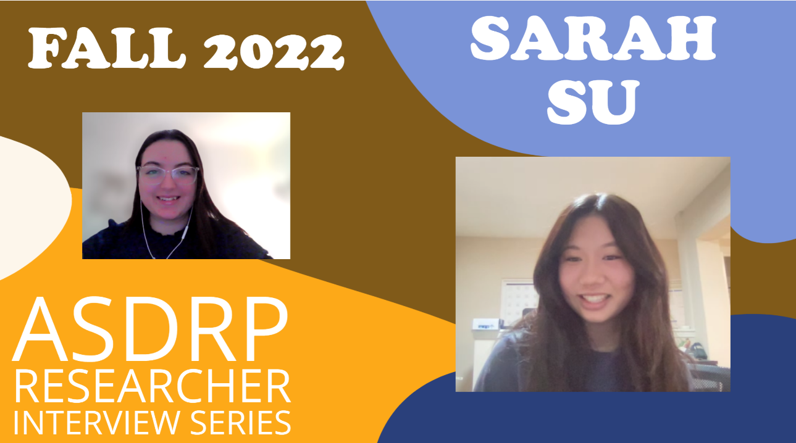

When asked what advice she’d give to a future researcher looking to join ASDRP, Sarah said:
“Reach out. Take initiative in your own research. Even if you're lost, even if you have no clue what is happening. Maybe write down a list of the words you don't understand and search them up when you get home. Just do your best to actively fight to join the discussion, to understand what is happening. Because once you understand, it’s a world of difference. You’re gonna be able to engage in such higher levels of research, you're gonna be able to understand what you're doing, and develop new ideas beyond what you're doing”

Staff Spotlights
Dayanna Chavez
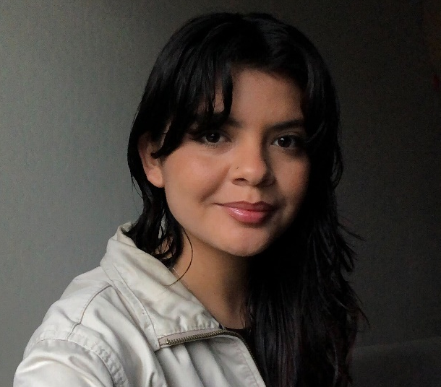
A word from Dayanna
“Hi everyone! My name is Dayanna Chavez, and I recently graduated from UC Davis with a B.S. in Biological Sciences. I am eager to work with ASDRP by continuing to support and uplift younger generations in STEM. I am also really excited to learn from the students, advisors, and staff!”

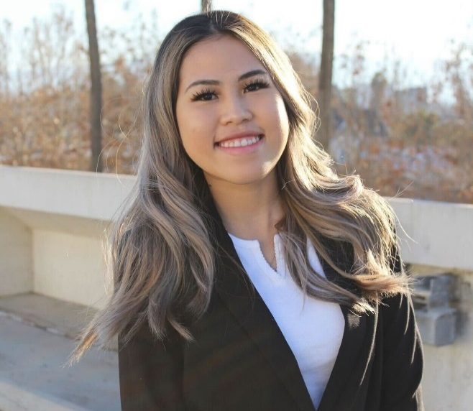
Tuyen Tran

A word from Tuyen
“I’d like to participate in a lab involving biology and chemistry, particularly one focusing on organic or biochemistry. I believe that joining ASDRP will provide me with the best possible access to a wide variety of research opportunities in the laboratory!”
Publication Shout-Outs
Congratulations to the McMahan group for their submission to the Journal of Emerging Investigators! Their manuscript “Hybrid Quantum-Classical Generative Adversarial Network for Synthesizing Chemically Feasible Molecules” revisions have been accepted and will be published soon!

Fall - Spring Transition
December 16, 2022 through January 4, 2023
ALL researchers must complete the form www.asdrp.org/check-in, whether they are
- Staying in the same group
- Switching groups (with permission)
- Leaving ASDRP

Holiday Hours at the Lab through Jan 6: 12:00 pm to 10:00 pm

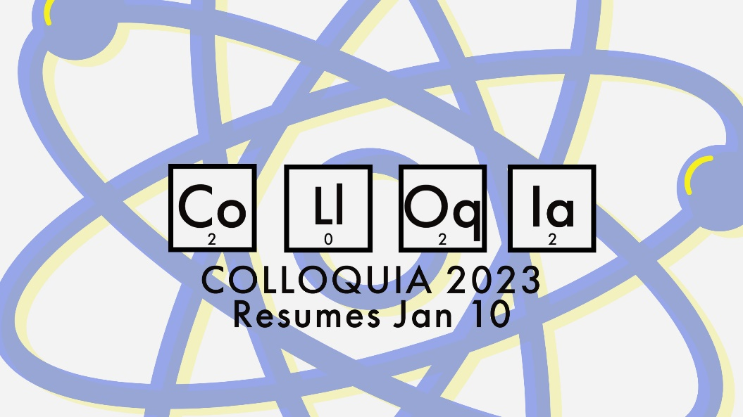

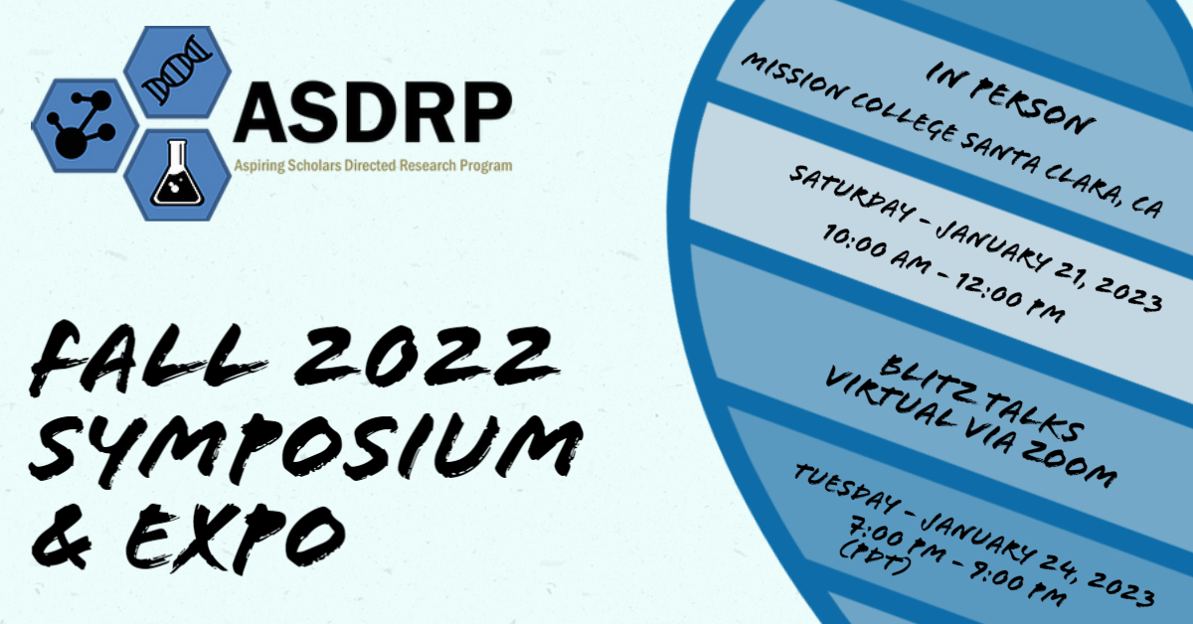

Connect with ASDRP!
Find us on LinkedIn Instagram Facebook Twitter YouTube Website

